**Improved Generation of Symmetric Cyclic Peptide Complexes with RFDiffusion**

**Rationale:** Cyclic peptides *(Figure 1)* have demonstrated promising potential for their structural stability, membrane and cell permeability, and high binding affinity in the field of pharmaceuticals and drug design.1 However, the *de novo* design of such molecules has been (A) mostly limited to classical, energy-based design techniques and (B) focused on design of cyclic peptides as monomers (that then associate with targets of interest), rather than as homo-oligomeric species. Recently, a generative neural network, RFdiffusion, have demonstrated successful generation of protein oligomers with high experimental success rates.2 Furthermore, recent findings have shown that manipulating the relative positional encoding of amino acids can generate cyclized peptide predictions using RFDiffusion.3 Leveraging these findings, we aim to combine RFDiffusion’s symmetric oligomer generation capability with that of producing cyclic peptides and explore their experimental feasibility.

*Figure 1. PyMOL Implementation of a cyclic peptide.*



Then, we will validate the robustness of those generated symmetric oligomers through comparative analysis with experimentally determined structures. This will be a cornerstone for efficient generation of symmetric conformation of macrocyclic polypeptides3

**Hypotheses:**

* We can make symmetric oligomers of cyclic peptides, and they maintain cyclic peptide properties such as cell permeability, increased binding affinity, and structural stability.
* We can gain more insights and controls over the designing process for *de novo* protein binders and other targets.

**Acknowledgement:** First and foremost, I would deliver my deepest gratitude to David C. Juergens for providing insightful guidance and professional mentorship to proceed with this research. In addition to him, I appreciate Dr. Gaurav for initiating cyclic peptide prediction research which is a main source of initiating this project.

**Objective:** Robust generation process of symmetric oligomers made of cyclic peptides.

**General Approach:** Our main approach for the robust generation and testing of symmetric oligomers of cyclic peptides will include following key steps.

* We will integrate the protocols in RFDiffusion for generating symmetric oligomers with its capacity to produce cyclized peptides *(Figure 2)*. This combination aims to harness the structural stability and high binding affinity of cyclic peptides.
* We can use cyclized peptides as the asymmetric unit. Then, we can generate complexes with diverse point group symmetries as shown in *Figure 2*.
* To design the sequences for these RFDiffusion backbone structures, we will use ProteinMPNN.4 This model will ensure that our generated structures have sequences with high performance and structural compatibility.
* We will use cyclic AlphaFold2 (AF2) structure prediction protocol to filter designs in silico and select designs for experimental validations.1
* We will perform comparative analysis using *r.m.s.d* and confidence metrics for validating robustness of generated structures.

*Figure 2. RF Symmetrized Inference. From “Motif Scaffolding in oligomers and repeat proteins” by David C. Juergens (Slide p. 5)*

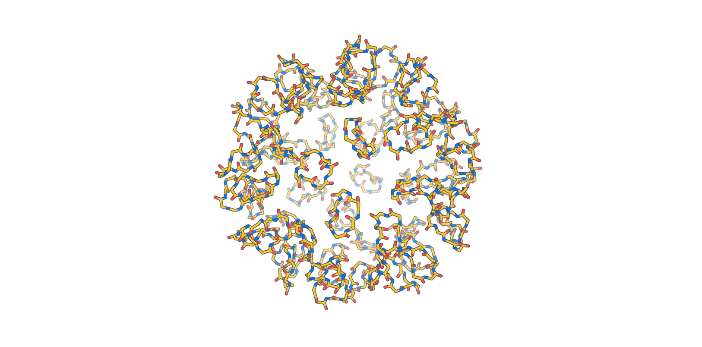

**References**

[1] Rettie, Stephen A, et al. *Cyclic Peptide Structure Prediction and Design Using AlphaFold*. 26 Feb. 2023, https://doi.org/10.1101/2023.02.25.529956.

[2] Watson, Joseph L., et al. *Broadly Applicable and Accurate Protein Design by Integrating Structure Prediction Networks and Diffusion Generative Models*. 10 Dec. 2022, https://doi.org/10.1101/2022.12.09.519842.

[3] Gaurav, Bhardwaj and Sergay Ovchinnikov (2023). *Unknown*.

[4] Juergens, David. (2023 June 12). Motif Scaffolding in oligomers and repeat proteins. Seattle, WA, United States.

[5] Dauparas, J., et al. *Robust Deep Learning Based Protein Sequence Design Using Proteinmpnn*, 2022, https://doi.org/10.1101/2022.06.03.494563.